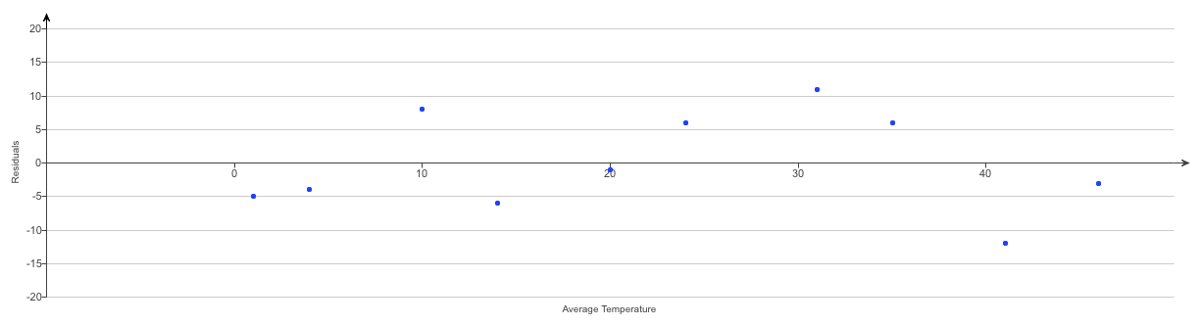
After keeping track of his heating expenses for several​ winters, a homeowner believes he can estimate the monthly cost from the average daily Fahrenheit temperature using the model Cost=129−1.95 temp. The residuals plot for his data is shown.

a) Interpret the slope of the line in this context. What does the model predict given a 1° increase in​ temperature?

A.
The model predicts a ​$129 increase in heating cost.
B.
The model predicts a ​$1.95 increase in heating cost.
C.
The model predicts a ​$129 decrease in heating cost.
D.
The model predicts a ​$1.95 decrease in heating cost.

​b) Interpret the​ y-intercept of the line in this context. What does the model predict given a temperature of 0°​?

A.
The model predicts a heating cost of​ $0.
B.
The model predicts a heating cost of ​$1.95.
C.
The model predicts a heating cost of ​$129.

​c) During the months when the temperature stays around freezing ​(32 degrees ° ​F), would you expect the cost predictions based on the model to be​ accurate, too​ low, or too​ high? Explain.
A.
Too low, because the residual is positive.
B.
Accurate, because the predicted and observed values are very close.
C.
Too high, because the residual is negative.

d) What heating cost does the model predict for a month that averages 10°​?
cost=​$_______
​(Round to the nearest cent as​ needed.)

​e) During one of the months on which the model is​ based, the temperature did average 10°. What were the actual heating costs for this​ month?

The actual heating costs for this month were ​$_________
​(Round to the nearest dollar as​ needed.)

f) Do you think the homeowner should use this​ model?
A.
No
B.
Yes

Question 3)
A group of high school seniors took a scholastic aptitude test. The resulting math scores had a mean 480.4 with a standard deviation of 190.1​, verbal scores had a mean 480.6 with a standard deviation of 162.3​, and the correlation between verbal and math scores was r=0.718. Complete parts a through f below.

a)What is the​ correlation?
The correlation is:_________
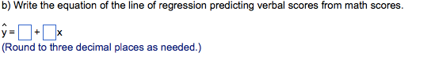

c) In​ general, what would a negative residual mean in this​ context?

- a negative residual means the student has
a higher verbal score than than the linear model would predict.
B.
A negative residual means the student has
the exact verbal score that the linear model would predict.
C.
A negative residual means the student has a lower verbal score than the linear model would predict.

​d) A person tells you her math score was 241. Predict her verbal score.
The student is expected to have a verbal score of ___.
​(Round to three decimal places as​ needed.)

​e) Using the predicted verbal score from part​ (d) and the regression equation Math=76.215 +0.841(verbal)​, predict the​ student's math score.

The predicted math score is:______.
​(Round to three decimal places as​ needed.)

​f) Why​ doesn't the result in part​ (e) come out to 241​?

A.
The line given in part​ (e) minimizes squared residuals in the verbal​ direction, while the line found in part​ (b) minimizes them in the math direction.
B.
The line found in part​ (b) minimizes squared residuals in the math​ direction, while the line given in part​ (e) minimizes them in the verbal direction.
C.
The line found in part​ (b) minimizes squared residuals in the verbal​ direction, while the line given in part​ (e) minimizes them in the math direction.

question 4)

The scatterplot to the right shows that the trend for the interest rate on a​ 3-month bond changed dramatically after​ 1980, so two regression models were fit to the relationship between the rate​ (in %) and the number of years since​ 1950, one for 1950 to 1980 and one for the data from 1980 to 2007. The accompanying display shows the plots of the interest rate on the​ 3-month bond from 1950 to 1980 and from 1980 to 2007 and their corresponding regression models. Complete parts a through d.
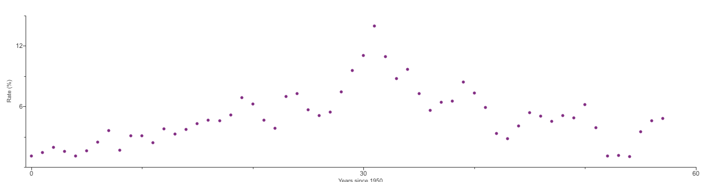
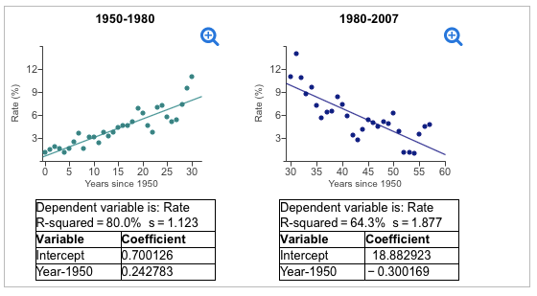
​a) How does the model for the data between 1980 and 2007 compare to the one for the data between 1950 and​ 1980?
A.
The model for the data between 1980 and 2007 fits the data much better than the other model.
B.
The models are approximately equal.

C.
The two models both fit​ well, but they have very different slopes.

​b) What does the model for the data between 1980 and 2007 estimate the interest rate to have been in 1995​? How does this compare to the predicted rate obtained from the model for the data between 1950 and​ 1980, which is approximately 12​%?

The model estimates that the interest rate was:______ ​% in 1995.
​(Round to one decimal place as​ needed.)

c) How does the predicted value from the model for the data between 1980 to 2007 compare to the predicted value from the model for the data between 1950 and​ 1980, which is approximately 12​%?

A.
The model for the data between 1980 and 2007 predicts the interest rate in 1995 to be much higher than the other model predicts.

B.
The model for the data between 1980 and 2007 predicts the interest rate in 1995 to be about the same as the other model predicts.

C.
The model for the data between 1980 and 2007 predicts the interest rate in 1995 to be much lower than the other model predicts.

​c) Do you trust this newer predicted​ value?

A.
Yes. R2=64.3% is large enough for the extrapolation to be safe
B.
Not really. Extrapolating 45 years beyond the beginning of these data would be dangerous and unlikely to be accurate.
C.
​Yes, because the​ x-value is within the range of the original data.
D.
Not really. Interest rates are too random to predict for any time.

​d) Given these two​ models, what would you predict the interest rate on the​ 3-month bond will be in 2020​?

A.
It would be best to take the mean of the predicted values from each​ model, which is about 8​%.
B.
It would be best to use the predicted value from the model for the data between 1980 and​ 2007, which is about 2​%.
C.
It would be best to use the predicted value from the model for the data between 1950 and​ 1980, which is about 18​%.
D.
It would be best not to predict the value because extrapolating beyond the​ x-values that were used to fit the model can be dangerous.

Question 5)

The accompanying table shows the height of the initial drop​ (in feet) and the duration of the ride​ (in seconds) of the 10 best roller coasters in a certain country. What do these data indicate about the height of the initial drop of a roller coaster and the duration of the​ ride, using correlation and a​ scatterplot?

Construct a scatterplot of the data. Choose the correct answer below. which is the correct scatter plot?
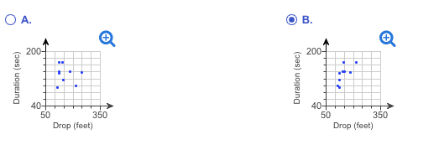
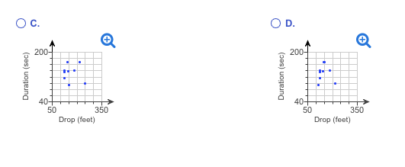
B) Calculate the correlation coefficient.

r=______
​(Round to three decimal places as​ needed.)

c) What do these data indicate about the height of the initial drop of a roller coaster and the duration of the​ ride?
A.
​Generally, rides on coasters with a greater initial drop tend to last
somewhat shorter​, because the correlation indicates a weak association.
B.
​Generally, rides on coasters with a greater initial drop tend to last
somewhat longer​, because the correlation indicates a moderate association.
C.
​Generally, rides on coasters with a greater initial drop tend to last
longer, because the correlation indicates a strong association.
D.
​Generally, rides on coasters with a greater initial drop tend to last somewhat longer​, because the correlation indicates a weak association.

